Session-7
Ǫuestion1: Create a table called Restaurant with columns: id, name, location, and cuisine. Apply NOT NULL constraint to name and location, and make id the PRIMARY KEY.
Ans:
CREATE TABLE Restaurant (
id INT PRIMARY KEY AUTO_INCREMENT, name VARCHAR(100) NOT NULL, location VARCHAR(100) NOT NULL,
cuisine VARCHAR(50)
);

Ǫuestion2: Create a table called FoodOrder with columns: order_id, restaurant_id, user_id, and order_total. Set order_id as PRIMARY KEY, and add a FOREIGN KEY constraint on restaurant_id referencing Restaurant(id).
Ans:
CREATE TABLE FoodOrder ( order_id INT PRIMARY KEY, restaurant_id INT,
user_id INT,
order_total DECIMAL(10,2),
FOREIGN KEY (restaurant_id) REFERENCES Restaurant(id)
);
Ǫuestion3: Insert 6 rows into a table called SpotifyUser with columns: user_id, username, email, and subscription_type. Ensure that username is UNIǪUE and email is NOT NULL.<br><br><em><strong>Hint:</strong> Use the UNIǪUE and NOT NULL constraints when creating the table.</em>
Ans:
CREATE TABLE SpotifyUser ( user_id INT PRIMARY KEY,
username VARCHAR(50) UNIǪUE, email VARCHAR(100) NOT NULL,
subscription_type VARCHAR(30)
);
INSERT INTO SpotifyUser (user_id, username, email, subscription_type) VALUES
(1, 'parthil', 'parthil@gmail.com', 'Premium'),
(2, 'aarav', 'aarav@gmail.com', 'Free'),
(3, 'kavya', 'kavya@gmail.com', 'Premium'),
(4, 'riya', 'riya@gmail.com', 'Free'),
(5, 'dev', 'dev@gmail.com', 'Premium'),
(6, 'isha', 'isha@gmail.com', 'Free');
SELECT * FROM SpotifyUser;

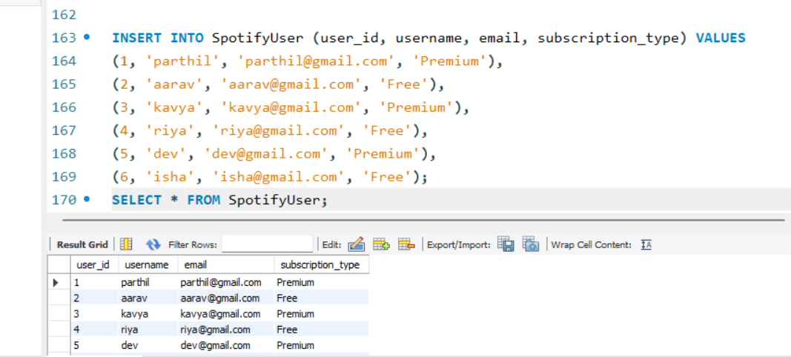
Ǫuestion4: Create a VIEW named TopSpendersView that shows usernames and order_total from a FoodOrder table where order_total is greater than 1000.
Ans:
CREATE VIEW TopSpendersView AS SELECT SpotifyUser.username, FoodOrder.order_total FROM FoodOrder
INNER JOIN SpotifyUser ON FoodOrder.user_id = SpotifyUser.user_id WHERE FoodOrder.order_total > 1000;

SELECT * FROM TopSpendersView;

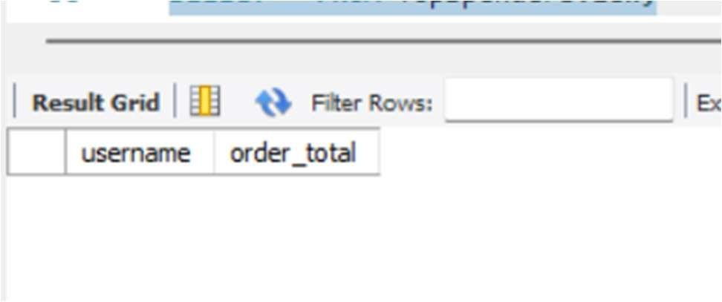
Ǫuestion5: Write a SǪL query to list all users from the TopSpendersView who have spent more than 2000, sorted by order_total descending.<br><br><em><strong>Constraint:</strong> Only use the TopSpendersView for your query, not the original FoodOrder table.</em>
Ans:
SELECT username, order_total FROM TopSpendersView WHERE order_total > 2000 ORDER BY order_total DESC;

